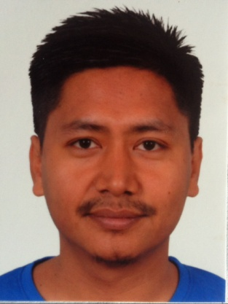
Dipu Maharjan
Analyst

Kirtipur-2 Dev Dhoka, Kathmandu, Nepal
contacttodipu@gmail.com (+977) 9841-700042

Professional Attributes | - Good organizational skills developed in a variety of deadline orientated situations.  - A critical thinker with strong analytical skill.  - Self-motivated.  - Efficient and can handle multitask.  - Knows the priority of task and set them according to achieve day to day goal.  - Strive for quality in everything I do.  - Get on well with people at all levels, easily making good working relationships.
Skills | Team Work, Team Management  Working with Oracle database 10g/11g  SQL queries and PL/SQL  Oracle Forms Developer / Oracle Apex  Programming knowledge (Java, JSF)  Accounting, Payroll Application
Experience | Verisk information technologies – Ktm 2012 Feb – Present  Analyst (Team Lead)  - Prepare the required scripts (Import, Analysis, Scrub scripts etc) in Oracle and SQL Server according to the client requirement.  - Observe and maintain the space available in Database during the client processing.  - SQL/PlSql Script optimization.  - Data as well as Script migration from SQL server to Oracle.  - Give training to new hire.  - Scheduling the daily task and divide them to the team members.  - Prepare Client based, work based report for management.  Mosaic Technologies pvt ltd – Ktm 2010 Feb – 2011 Dec  Ass. Oracle Developer  - Develop Oracle Forms and Reports according to the client request.  - Updating the Software operating manual.  - Give training to the new users.  - Hardware and software support to the client
Education | Tribhuwan University – Sahid Smarak College, Ktm 2010 - 13  Bachelor in Business Studies  tribhuwan university– NCE, Ktm 2005  BEX (2005th Batch, drop out in 3rd year)  HSEB – Bernhardt College, Ktm 2002 - 04  +2 in Science  HMG – Hill Town International School, Ktm 2002  School Leaving Certificate
Certification | Oracle certified professional  Oracle Database 11g
Training | Oracle Database 11g Workshop II  (Mentors, Hyderabad)  Oracle Certified Professional (OCP) 10g  (New Horizon CLC, Ktm)  Advance Java  (JSF with Spring Framework -NIIT)  Computer graphics – (4 month course)  (Adobe pagemaker 6.5, Photoshop 6, Macromedia freehand 9, corel draw 10)  Diploma in Computer – (9 months course)  (Computer Hardware, Networking & Troubleshooting, Database Management)
Personal Detail | Father’s Name : Buddhi Lal Maharjan  Date of Birth : 1986/11/15  Nationality : Nepali  Gender : Male  Marital Status : Married (Have Daughter)  Address : Kirtipur-2, Kathmandu  Religion : Buddhist  Language known : English, Nepali, Nepal Bhasaa, Hindi
Reference | Upendra Mahrajan Director of Mosaic Technologies Pvt. Ltd. (9851046446)  Om Chandra Rimal Manager at Verisk Information Technologies (9803001353)

